Steps:
1. Load Arduinio Code onto board
2. Start ROS nodes

Step 1:
a). Uploading the Arduino code is done through the IDE
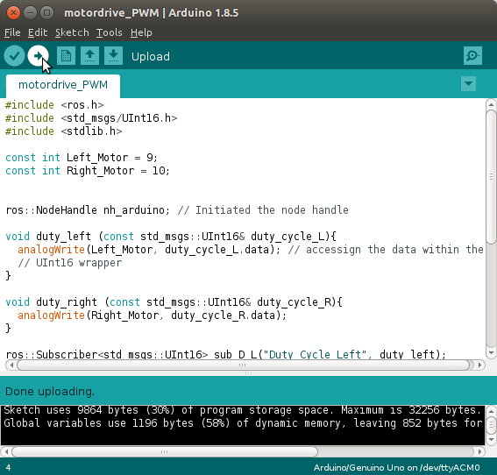
b). Make sure that Arduino is connected to the computer through a USB port

Step 2.:
a) Execute the following commands in this order
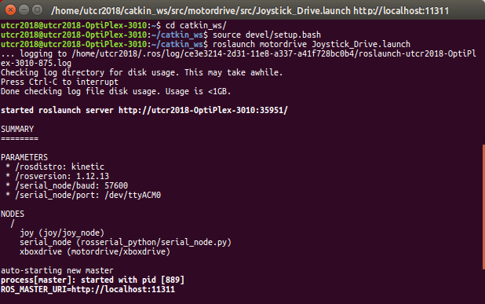
b) your rqt_graph should look like this:
Execute the command ‘rqt_graph’ in a separate terminal window
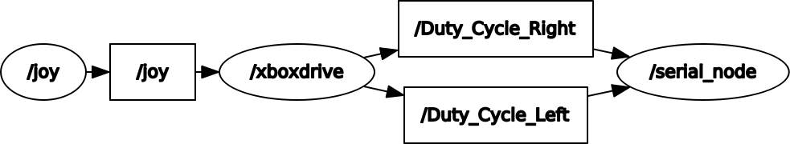

Driving the robot:
1) pushing A starts the robot – green light will turn on
2) left stick will move forwards and backwards
3) right stick will steer like a jet ski – must be moving under power to steer

If the Arduino does not connect, try roslaunch motordrive Joystick_Drive.launch port:=/dev/tty/ACMX where X is 1,2,3,4….

